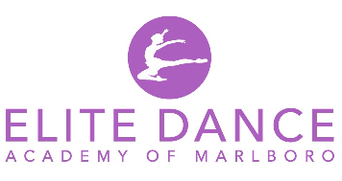

479 Highway 79
Morganville, NJ 07751
(732) 591-9700

DANCE CAMP REGISTRATION FORM
WEEKS REGISTERING FOR:
(PLEASE CIRCLE)
DISNEY’S WISH: JULY 8TH – JULY 11TH
TAYLOR SWIFT: JULY 15TH – JULY 18TH
BARBIE: JULY 22ND – JULY 25TH
TROLLS BAND TOGETHER: JULY 29TH – AUGUST 1ST
ILLUMINATION’S MIGRATION: AUGUST 5TH – AUGUST 8TH
$225.00 PER WEEK
CAMPS RUN MONDAY-THURSDAY FROM 9:00 A.M. – 1:00 P.M.
NO REGISTRATION FEE!!!

PARENTS NAME ____________________________________ DATE _______________
STUDENT NAME ________________________________________________________
ADDRESS _____________________________________________________________
CITY _____________________________ STATE _______ ZIP CODE ______________
PHONE ( )______________________ CELL PHONE ( )__________________
ALT CELL PHONE ( )_________________ STUDENT AGE ____________________
BIRTHDATE __________________
ANY MEDICAL CONDITIONS WE SHOULD KNOW ABOUT? ________________________
IF YES, PLEASE EXPLAIN ____________________________________________________________________________________________________________________________________________
HOW DID YOU HEAR ABOUT US? ____________________________________________
EMAIL ADDRESS _________________________________________________________
ALTERNATE EMAIL ADDRESS _______________________________________________

OFFICE USE ONLY
AMOUNT PAID ______________ DATE _____________
PMT TYPE: CHECK #______ CASH CREDIT: VISA MASTERCARD DISCOVER AMEX VENMO ZELLE
CASH RECEIPT #________ PUT INTO DANCEWORKS BY: ___________
7/8-7/11 _____ 7/15-7/18 _____ 7/22-7/25 _____ 7/29-8/1 ______ 8/5-8/8 ______

